What is Terraform

Terraform helps you manage all of Your Infrastructure as infrastructure as code and promote Self-Service Infrastructure allows you to contract infrastructure you need.

Terraform is a tool for creating, updating, and versioning infrastructure securely and efficiently.

The most useful commands in terraform

Terraform init:- Initialize the current directory

Terraform plan; - Dry run to see what terraform will do

Terraform apply: - apply the Terraform Code

Terraform destroy: - Destroy what was built by Terraform

Terraform refresh: - Refresh the State file

Terraform output: - View Terraform output

What is module in terraform

A module is a container for several resources that are used to conjunction with one another

| ---- License

| ---- Readme.md

| --- main.tf

| --- variables.tf

| -- output.tf

The Terraform language is HashiCorp Configuration Language

What is Terraform State file

Terraform keeps track of the resources it has created in State file. The crucial information contains all the information terraform required to change, update and delete infrastructure

Terraform lab

Take one Aws instance

Install Terraform in that instance using below three links

sudo yum install -y yum-utils

sudo yum-config-manager --add-repo <https://rpm.releases.hashicorp.com/AmazonLinux/hashicorp.repo>

sudo yum -y install terraform

check aws cli is present or not

configure aws using command (aws configure)

check terraform version using the command (terraform --version)

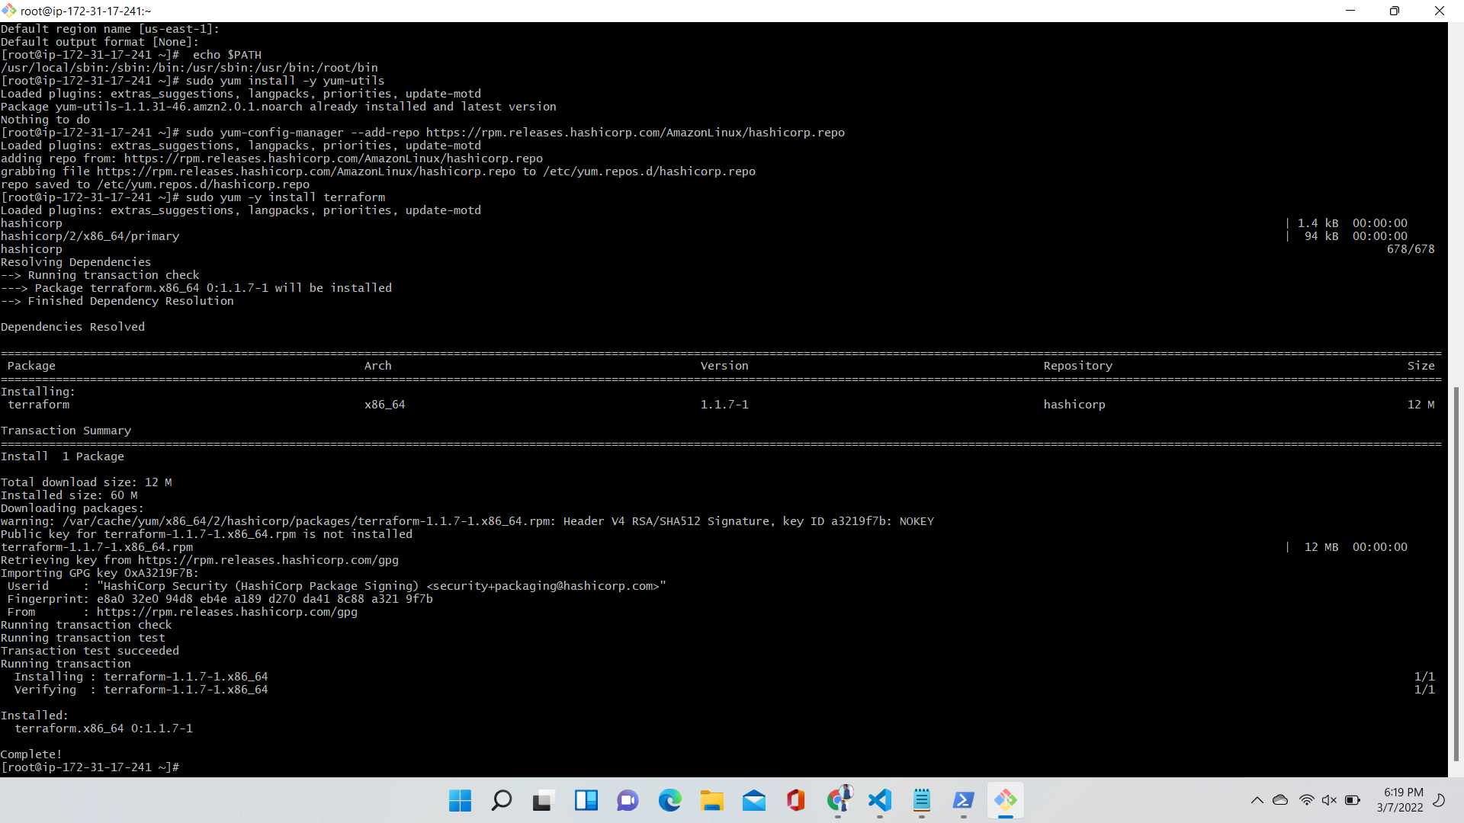

Terraform init:- Initialize the current directory

Vi var.tf

variable "amiid" {

description = "AMI id of instnce"

default = "ami-005d843eadb96ed7f"

}

variable "instancetype"{

default = "t2.micro"

}

variable "instances" {

default = "2"

}

Vi main.tf

provider "aws"{

region = "us-east-1"

}

resource "aws_instance" "name" {

ami = "${var.amiid}"

instance_type = "${var.instancetype}"

count = "${var.instances}"

tags = {

Name = "Tcreated - ${count.index}"

}

}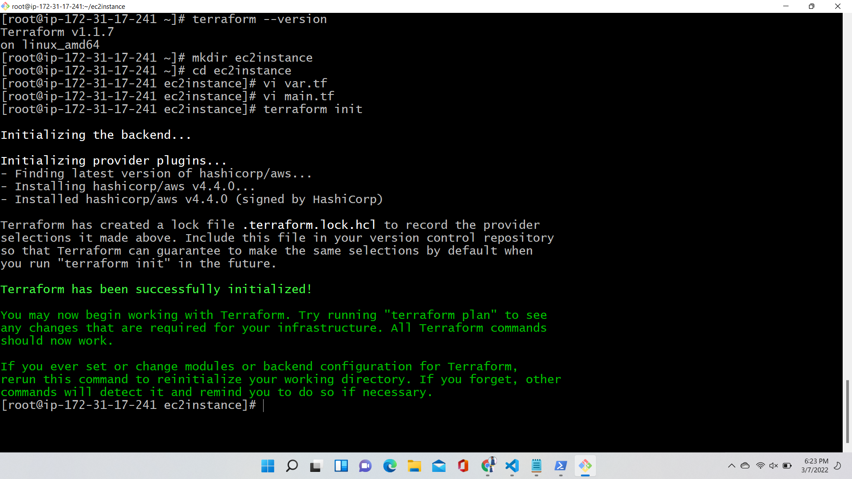

Terraform apply: - apply the Terraform Code

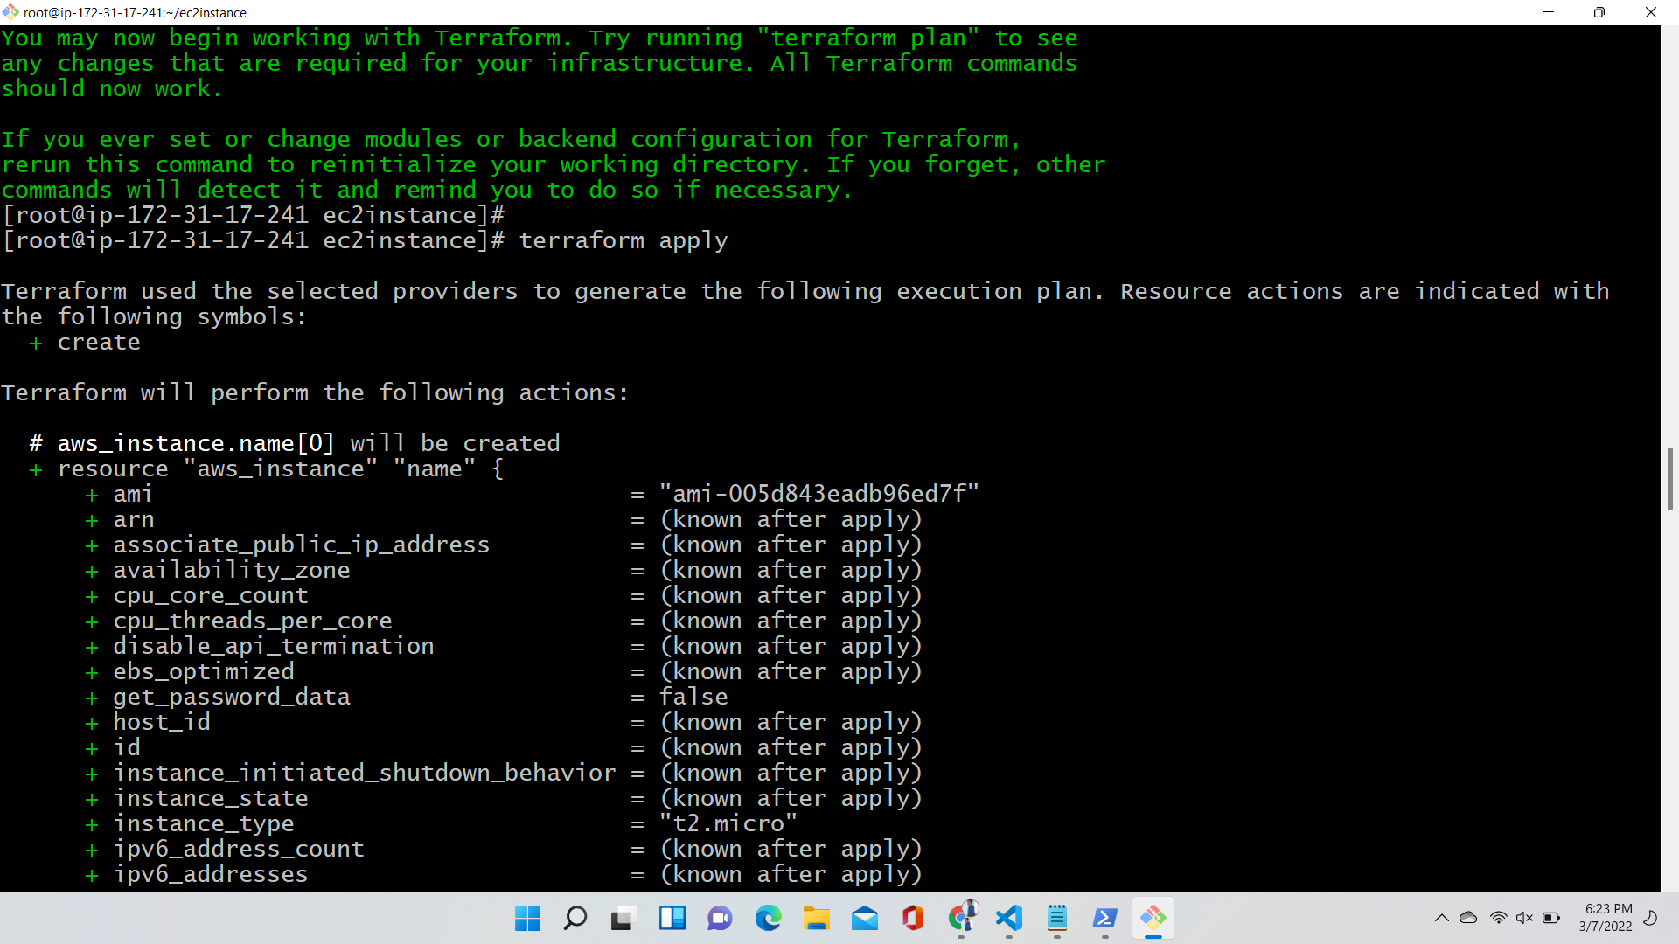

After applying here two instance have been created in aws

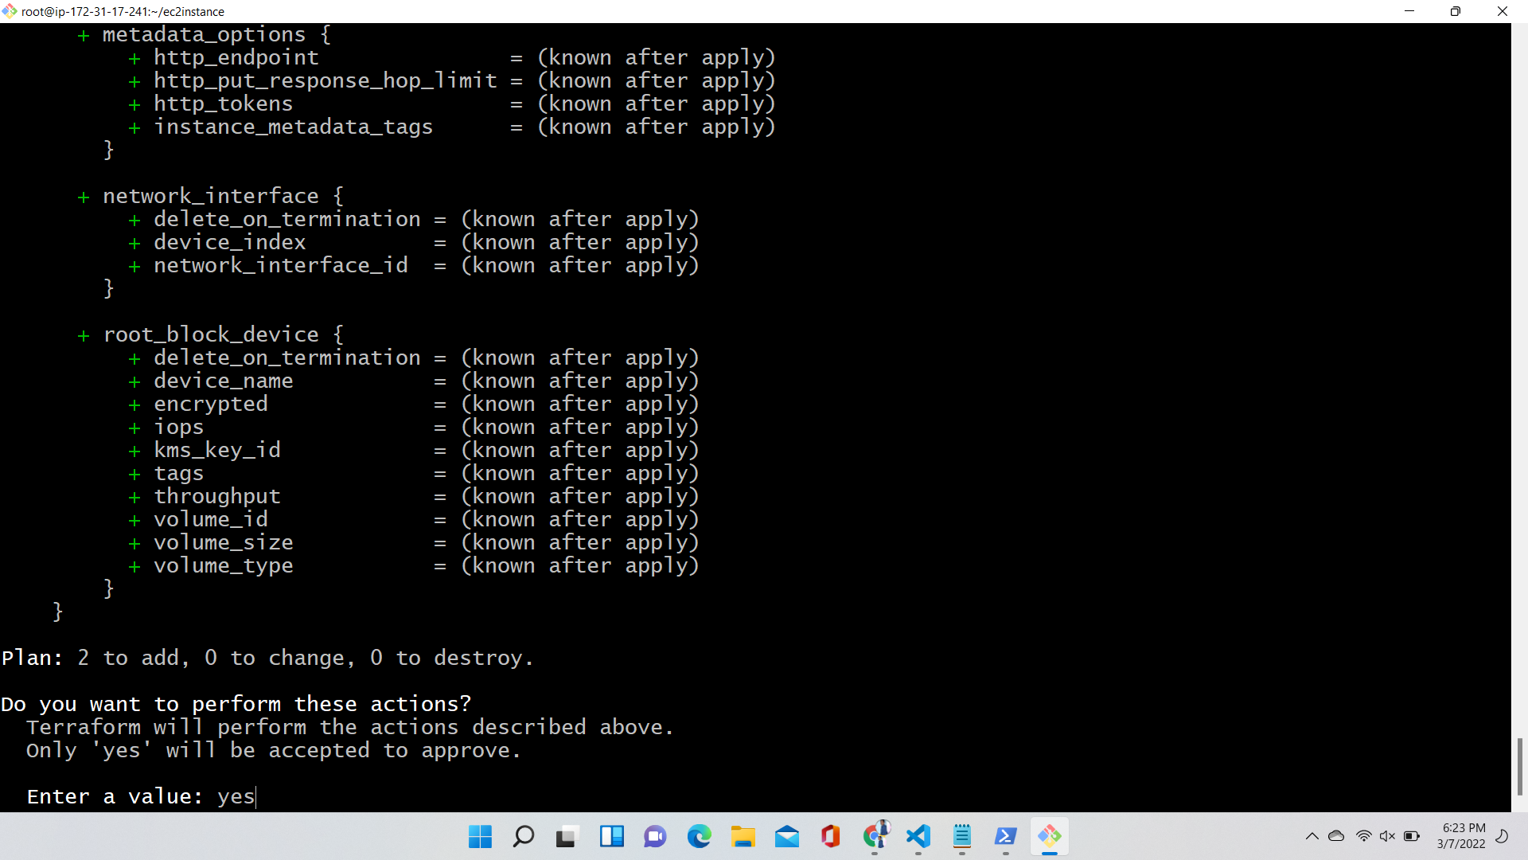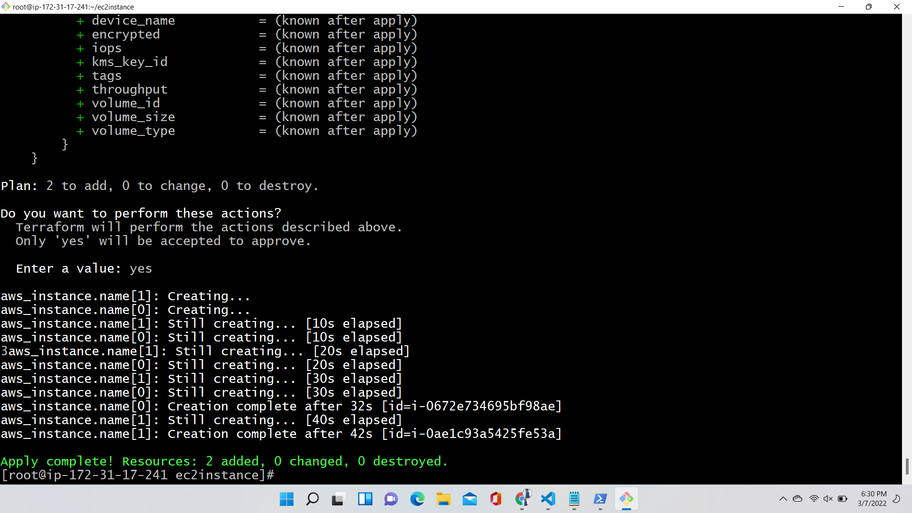

Tcreated and tcreatedo are the two instance are created in our aws through terraform

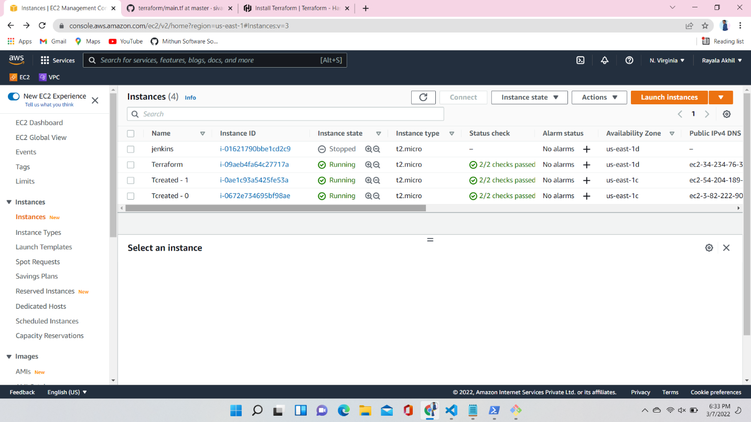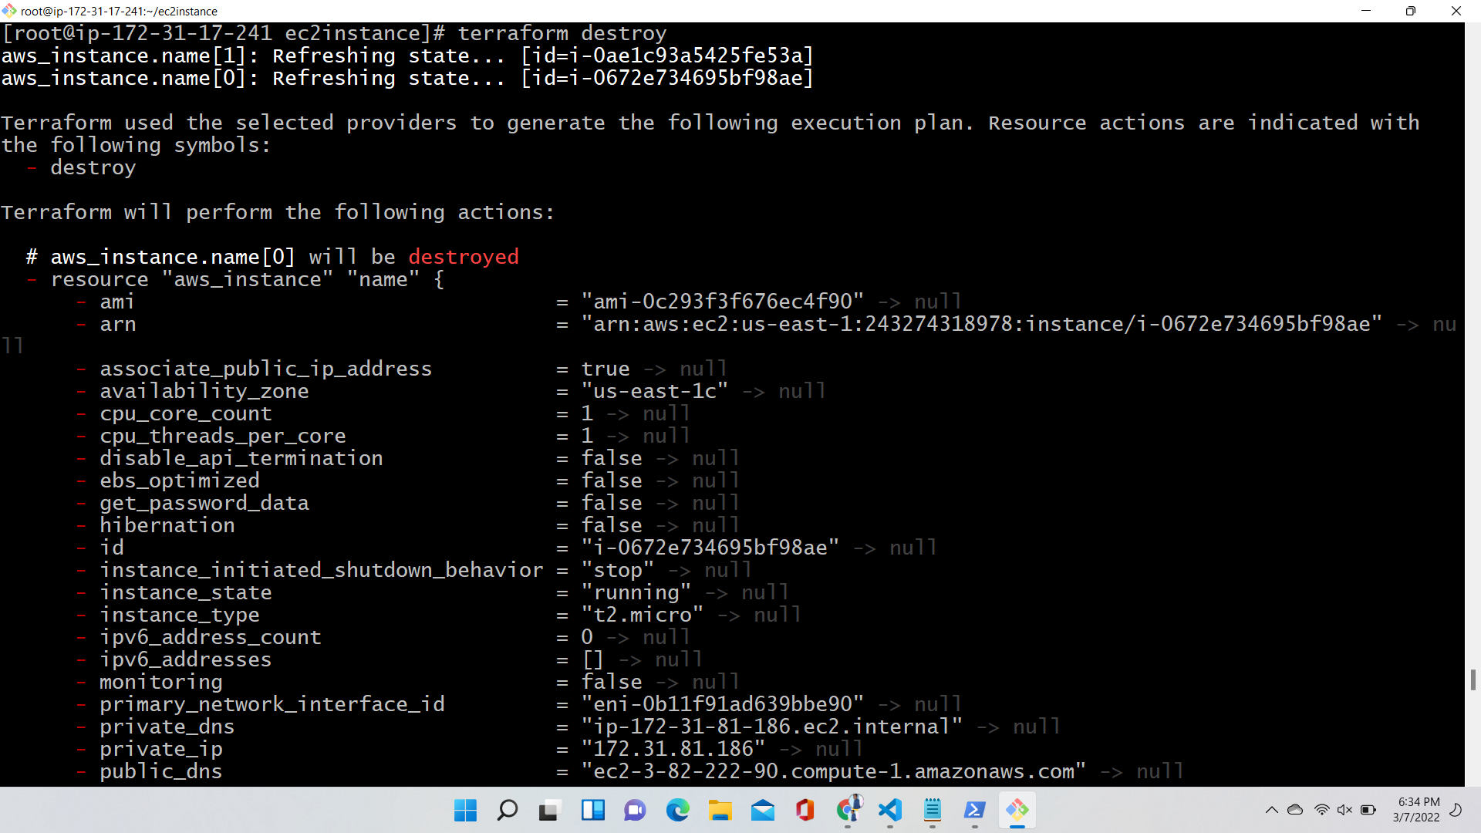

Here I am destroyed that aws instances through terraform aws destroy is the command

